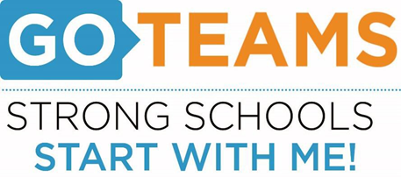

**MEETING NOTICE**

|  |  |  |  |
| --- | --- | --- | --- |
| **School** | **Date** | **Time** | **Location** |
| August 21, 2024 | 4:00pm – 6:00pm | [**https://atlantapublicschools-us.zoom.us/j/86844117045?pwd=bWxoZ0FQNktIVndtWXY2Mm4yVEtTdz09**](https://atlantapublicschools-us.zoom.us/j/86844117045?pwd=bWxoZ0FQNktIVndtWXY2Mm4yVEtTdz09)    **Meeting ID: 868 4411 7045**  **Passcode: GoTeam**  **Youtube: Tommy Tyson@tommytyson5756** |  |

**Notice Prepared By:** Briana Spence **Date Posted: 8/14/24 .**

**Meeting Agenda**

(*agenda may be amended*)

*This meeting will not allow for Public Comment*

1. **Action Items** 
   1. Approval of Agenda
   2. Fill Vacant Positions
   3. Fill Open Community Member Seat
   4. Approval of Previous Minutes
   5. Election of Officers and Representatives
      1. Chair
      2. Vice-Chair
      3. Secretary
      4. Cluster Representative
   6. Review and Approve Public Comment Protocol
   7. Set GO Team Meeting Calendar
   8. Review, Confirm/Update, and Adopt GO Team Meeting Norms
2. **Discussion Items: *None***
3. **Information Items: *None***
4. **Announcements**
   1. 2024 Go Team G# Summit-**late September 2024**- more info to come
   2. New Go Team Member Training and Orientation
   3. GKids Testing (Kindergarten: ongoing
   4. Map Testing (K-5): 8/19 – 8/26
   5. Pancakes with Principal: 8/23
   6. MAP Fluency (K-3): 8/26 – 8/30
   7. HBCU Week: 9/9 – 9/13
   8. Food Pantry: 9/11
   9. Grandparents Brunch: 9/12
   10. Reading Buddies: 9/18
   11. Book Fair: 9/23 – 9/27
   12. Academic Tailgate: 9/26
5. **Adjournment**